

**AMERICAN INTERNATIONAL UNIVERSITY- BANGLADESH**

**(AIUB)**

**Introduction to Electrical Circuit**

**FALL 2023-2024**

**Section: L, Group: 07**

**LAB REPORT ON**

***Study of Thevenin’s Theorem***

**Supervised By**

**MD. SHAHARIAR PARVEZ**

|  |  |
| --- | --- |
| **Name** | **ID** |
| **1.MD. Abdullah** | **22-48065-2** |
| **2.Azmir Islam Kafi** | **22-47981-2** |
| **3.Mohammad Ansar Uddin** | **22-47975-2** |
| **4.Chinmoy Guha** | **22-48056-2** |
| **5.Suvra Chakraborty** | **22-48067-2** |

# Abstract:

Thevenin’s theorem is an analysis technique. It can convert the complex circuit to a simpler series equivalent circuit for easier analysis. The analysis involves removing part of the circuit across two terminals to aid calculation, later combining the circuit with the Thevenin equivalent circuit.

# Apparatus:

* Trainer Board
* Voltmeter
* Ammeter
* AVO meter or Multimeter
* DC source
* Resistors

**Circuit Diagram:**

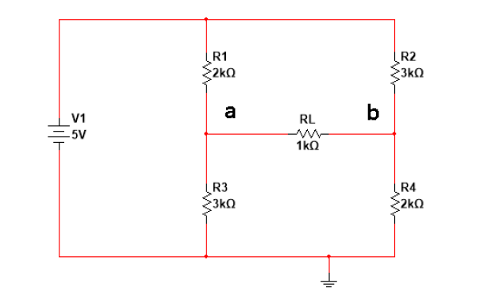

# Experimental Data and Procedure

The Thevenin's equivalent circuit analysis involves several key steps. Initially, a specific portion of the circuit is isolated for simplification and analysis. Then, voltage sources within this segment are temporarily short-circuited, while current sources are replaced with open circuits. This manipulation allows for the determination of the Thevenin equivalent resistance, often denoted as RTH, which represents the effective resistance between terminals A and B. After this, the original configuration of sources is restored, and the open-circuit voltage between terminals A and B is measured, referred to as VTH. To validate the accuracy of Thevenin's theorem for the given circuit, the obtained parameters are used in the equivalent circuit model.

|  |  |  |  |
| --- | --- | --- | --- |
| Thevenin Equivalent  Voltage (Eth) | | Thevenin Equivalent  Resistance (Rth) | |
| Measured Value (Experimental) | Calculated Value/ Simulate Value | Measured Value (Experimental) | Calculated Value/ Simulated Value |
| 1V | 1V | 2.4k ohm | 2.4k ohm |

# Result and Calculations

1. **Theoretical Calculations:**

R1 = 2k ohm R2 = 3k ohm R3 = 3k ohm R4 = 2k ohm

Rth = R1 | | R3 + R2 | | R4 = 2.4k ohm

Va = (R1/R1+R3)*5V = 2V

Vb = (R2/R2+R4)*5V = 3V

Eth = Vb-Va = 1V

# Simulation:

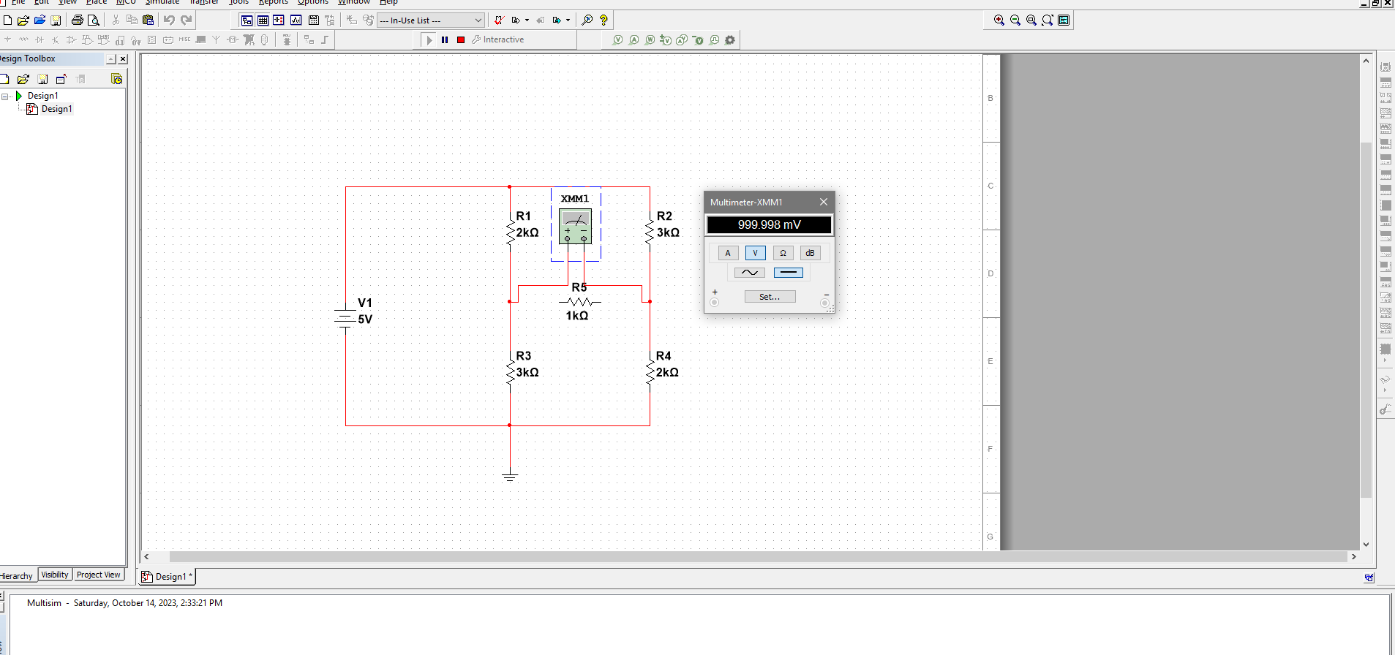

Fig: Vth

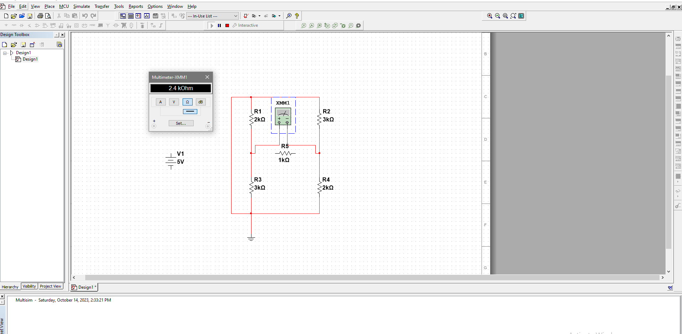

Fig: Rth

# 

# Discussion and Conclusion

The purpose of this experiment was to Study Thevenin’s Theorem. Through this experiment, the Thevenin theorem concept was practically visualized. The purpose of this experiment is to find the Thevenin equivalent circuit and measure Vth and Rth. The experimental values were quite accurate because they were close to the calculated value. Therefore we can conclude that the experiment was indeed successful.